Tashi Chime Gatsal Nunnery



**AFCA - Vacation with a Purpose (“VWP”)**

**Bigu, Nepal**

What could be more memorable than spending a week in a serene Nepalese village in a Tibetan Buddhist Nunnery!?! Our teams stay and work at the Tashi Chime Gatsal Nunnery in the remote village of Bigu, Nepal. Bigu is a small, peaceful Sherpa village located at @8200 feet in elevation, looking down onto a beautiful valley that offers amazing scenery – which is extra special at sunrise after morning meditations. There is only one road leading into the village, which is often unusable. Most of the time, the only traffic you willl see is people on foot and/or the occasional cart (and a far amount of livestock!).

While in Bigu, we are able to participate in most every aspect of the daily lives of the nuns, making for many fabulous memories.

### 

This is a self-directed volunteer experience – each day you can decide what you would like to do, how you would like to help, and how you would like to spend your time. Let us know what special skills you have, and we’re sure we can put them to use!

Here are a few projects that team members might help with:

* Minor construction and painting projects
* Teaching English
* Teaching classes on basic first aid, women’s health, nutrition, hygiene
* Providing basic medical care
* Helping the nuns with their daily chores, such as cooking meals and tending the gardens

We also offer Nepalese language classes each day, as well as special classes such as learning to cook traditional Nepalese and Tibetan foods – YUM! You are also welcome to attend any of the pujas (prayers) in the temple.

You can also choose to use your time to explore the village, hike, meditate, read, or relax. The nuns are also eager to share their culture. It is all up to you to decide where to spend your time.

### 

**Getting There**

Because Bigu is so remote, it takes some time to get there. Our journey to Bigu begins with a long jeep ride starting out in Kathmandu (about 5 hours) to the base of the mountain, then some slow going over pretty bumpy hillside roads (about 2 -3 hours). We hike a bit (about 45 minutes) and spend the first night at a rustic eco-lodge, before completing the journey to Bigu the next day.

### 

On the second day, there are **two ways** to travel to Bigu.

The **First Option**, for those looking for a physical (and mentally cleansing) experience, is to hike in. The hike is fairly strenuous, and we usually are able to divide into two groups if needed – one that takes the more direct route (5-6 hour hike) and one that takes the less-steep, meandering “road” (6-8 hour hike). The trail can be challenging with steep parts intermixed with less difficult treks across open meadows. Your gear will be taken up to Bigu for you, but you will need to carry a daypack with the items you will need during the hike.

***Don’t let the physical challenge discourage you from considering this opportunity.*** You do not need to be a super-athlete to complete the trek, but you do need to be prepared for a long, challenging day. And the reward for your efforts will be repaid immeasurably by the spectacular views along the way and the incredible feeling of accomplishment you will have when you arrive at the nunnery!

The **Second Option** is taking a jeep all the way to Bigu. It means a significantly longer jeep ride, but this is a great option for anyone wanting to avoid the challenging hike. **NOTE: There is a surcharge for this extended jeep ride** – see Trip Cost section.

### 

**Accommodations**

There are **two options** for accommodations:

The **standard accommodations** are shared rooms in rustic buildings inside the monastery compound. You will be using asian-style squat toilets (that are actually really nice compared to many we have seen!), located near the sleeping quarters. Showers are available (also across the compound). These are heated by solar panels, and we share the showers with the nuns, so be prepared for the possibility that hot water may not always be available. If you bring your own solar shower bag (you can buy one for $10-$15), you will have more likelihood of having a warm shower each day. We recommend this option. It’s a bit noisy and lacks some creature comforts, but it puts you right in the center of the nuns’ lives!

For those who have already been to Bigu or just want to stay in accommodations that are a bit more private and comfortable, you can stay in the new nunnery Guest House. The Guest House is situated just outside of the inner compound, but still within the nunnery grounds. It has a full kitchen, communal space and outdoor areas with spectacular views. **The best news** - there are two indoor, western-style flush toilets as well as two showers! These are also heated by solar panels, so somewhat weather dependent, but you only share them

with others in the guest house. And you can heat water in the kitchen for a bucket bath if necessary. **NOTE: There is a surcharge to stay in the guest house** – (see Trip Cost section) – **and space is limited, so it’s first come, first reserved.**

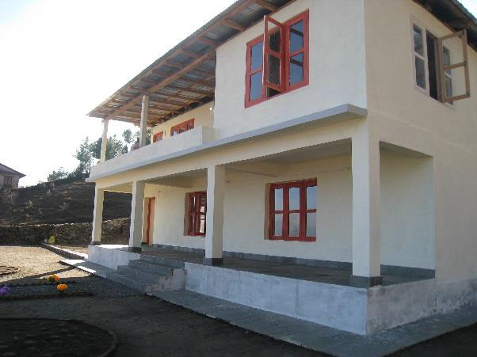

# Trip Logistics:

For most, flights will take a couple of days to get to Kathmandu from the U.S. The teams meet there, due to long flights (most flights to Nepal requiring an overnight layover) and the time difference. Along with the travel days, the typical schedule includes:

* two days for travelling to Bigu;
* seven days in Bigu;
* two days to travel back to Kathmandu;
* two nights in Kathmandu after returning from Bigu for sightseeing and shopping

And for those with time either before or after our time in Bigu, a world of wonders and adventure await you in Nepal!

This volunteer opportunity is in support of **“Climb Up So Kids Can Grow Up”**, a fundraising initiative in support of the **American Foundation for Children with AIDS (www.afcaids.org).** This volunteer experience raises funds for life-saving anti-retroviral (ARV) medication, supplemental food, and medical and humanitarian supplies for children affected or infected by HIV/AIDS in Sub-Saharan Africa. In addition, it increases awareness of the pediatric AIDS pandemic. As this is a fundraiser for AFCA, we strongly encourage team members to fundraise above the stated fees in support of this very important work!

Fees cover the majority of expenses while in-country. Included are the following:

## Donation to AFCA as well as an in-country coordinating partner, a non-profit called “Himalayan Guge Organization”

* All meals in Kathmandu and Bigu
* Sleeping accommodations in Kathmandu and Bigu
* In-country transportation, to and from the airport as well as to and from Bigu
* A portion of the team leader costs

The trip fees **do not include** airfare from your home to the host country; accommodations outside of the official trip dates; medical / emergency evacuation insurance; trip cancellation insurance; visa and exit fees (not applicable for all destinations); vaccinations.

**SURCHARGE FOR JEEP ALL THE WAY TO BIGU** (minimum of 2 people required): $100 EACH

**SURCHARGE FOR STAYING IN GUEST HOUSE**: $250

### 

We hope you’ll consider joining us in BIGU!!